

**Department of Electrical Engineering**

**Optional 3: Selectable Counter**

Name: Socheath Sok, ID: 014470701

Professor: Dr. Ray Wang

Class: EE 301

Date Due: December 11, 2017

**Explanation**

For this lab, the goal is to change the asynchronous up counter, created in lab 5, into a selectable counter that can perform both up and down counting modes. The mode of the counter will control by an input and that input signal will be combined with the output Q into and AND gate. The inverse signal will combine with the output Qn (the inverse of Q) into another AND gate. The outputs of both gates will then become the inputs to a third AND gate with its output connected to the clock input of the second J-K flip flop. The output of the third AND is also one of the main output listed in the structural code. The same set up will be connected to the clocks of the third and fourth flip flops. For the first flip flip, the clock input will be connected to the main clock signal and as for the last flip flop, Q will not be connected to anything and will be last output. Qn, on the other hand, will remains open.

**Code for JK flip flop**

library IEEE;

use IEEE.STD_LOGIC_1164.ALL;

entity jkff_2 is

Port ( j : in STD_LOGIC;

k : in STD_LOGIC;

clr : in STD_LOGIC;

clk : in STD_LOGIC;

q,qn: out STD_LOGIC);

end jkff_2;

architecture Behavioral of jkff_2 is

signal s : std_logic := '0';

begin

Process (clk,j,k,s,clr)

begin

if (clk' EVENT and clk = '1') then

if clr = '0' then s <= '0';

else

if j = '0' and k = '0' then s <= s;

elsif j = '0' and k = '1' then s <= '0';

elsif j = '1' and k = '0' then s <= '1';

Else s <= not s;

end if;

end if;

end if;

q <= s;

qn <= not s;

end process;

end Behavioral;

**Structural Code**

library IEEE;

use IEEE.STD_LOGIC_1164.ALL;

entity UC_2 is

Port ( clock, m : in STD_LOGIC;

clr : in STD_LOGIC;

Q : out STD_LOGIC_VECTOR (3 downto 0));

end UC_2;

architecture Behavioral of UC_2 is

component jkff_2

Port ( j : in STD_LOGIC;

k : in STD_LOGIC;

clr : in STD_LOGIC;

clk : in STD_LOGIC;

q,qn: out STD_LOGIC);

end component;

signal s : std_logic_vector(3 downto 0) := "0000";

signal a,b,c,d,x,y,z: std_logic :='0';

begin

R1: jkff_2 port map('1','1',clock,clr,s(0),a);

x <= (s(0) and not m) or (a and m);

R2: jkff_2 port map('1','1',x,clr,s(1),b);

y <= (s(1) and not m) or (b and m);

R3: jkff_2 port map('1','1',y,clr,s(2),c);

z <= (s(2) and nott m) or (c and m);

R4: jkff_2 port map('1','1',z,clr,s(3),d);

Q <= s;

end Behavioral;

**TestBench**

library IEEE;

use IEEE.STD_LOGIC_1164.ALL;

use IEEE.STD_LOGIC_unsigned.ALL;

USE ieee.std_logic_arith.ALL;

ENTITY UC_2T IS

END UC_2T;

ARCHITECTURE behavior OF UC_2T IS

COMPONENT UC_2

Port ( clock, m : in STD_LOGIC;

clr : in STD_LOGIC;

Q : out STD_LOGIC_VECTOR (3 downto 0));

END COMPONENT;

signal clock : std_logic := '0';

signal clr : std_logic ;

signal m : std_logic := '0';

signal Q : std_logic_vector(3 downto 0);

constant clock_period : time := 10 ns;

BEGIN

uut: UC_2 PORT MAP (

clock => clock,

Q => Q,

m => m,

clr => clr );

clock_process :process

BEGIN

clock <= '1';

wait for clock_period/2;

clock <= '0';

wait for clock_period/2;

end process;

stim_proc: process

begin

clr <= '0';

wait for 20 ns;

clr <= '1'; m <= '0';

wait for 50 ns;

clr <= '0'; m <= '1';

wait for 20 ns;

clr <= '1'; m <= '1';

wait for 50 ns;

wait ;

end process;

END;

**WaveForm**

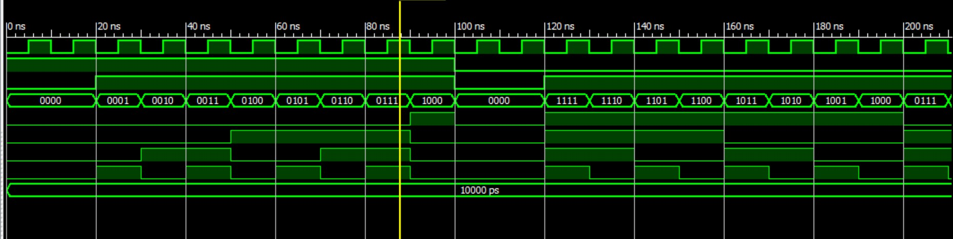

**Constraint File**

NET "clock" CLOCK_DEDICATED_ROUTE = FALSE;

NET "clock" LOC = "G12";

NET "Q(0)" LOC = "M5" ;

NET "Q(1)" LOC = "M11" ;

NET "Q(2)" LOC = "P7" ;

NET "Q(3)" LOC = "P6" ;

NET "m" LOC = "P11" ;

NET "clr" LOC = "N3";